In order to naviagate from one page to another through markeup link.

Client side development = html , css , javascript.

Html, css, javascript = structure, styling , functionality and actions performing.

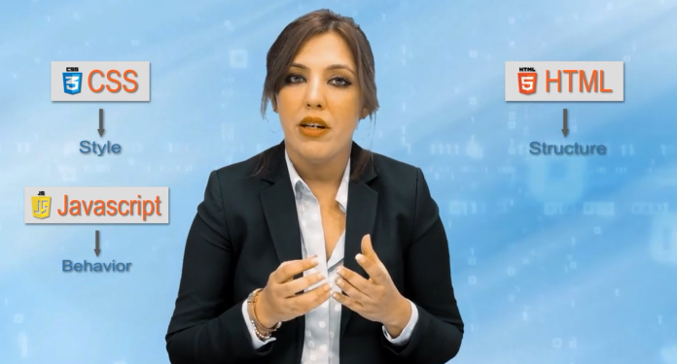

How to structure your webpage.

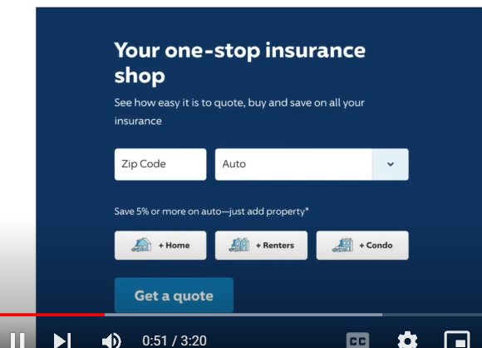

***Elements into structure of html:***

Elements used To describe the structure of your webpages.

<> = everything inside this tags called elements

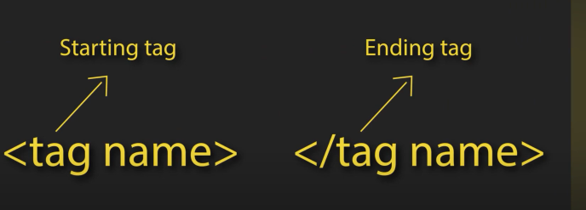

***structure of html:***

1. Html tag start with exclamation mark then press enter.
2. head tag
3. body tag

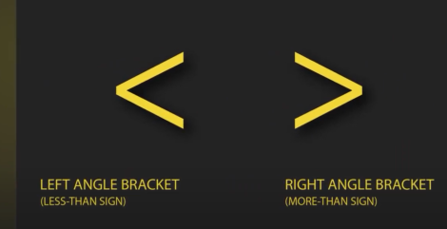

Tags and elements:

Every tage have starting and closing tag

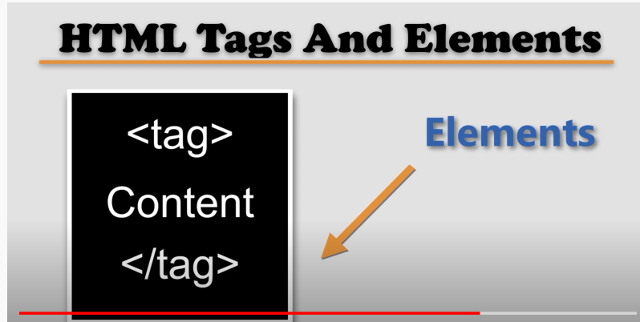

Anatomy of tags :

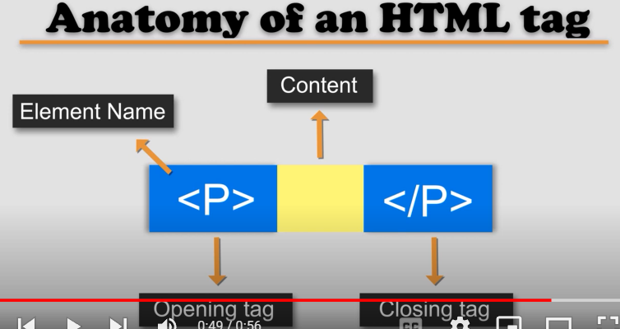

Attributes:

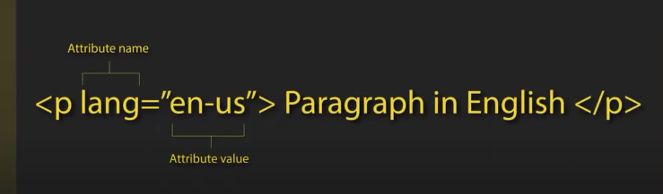

Body tag = contain visible page content.

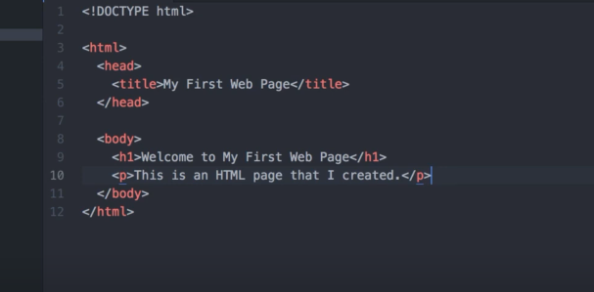

Let browser know about paragraph is Is in US English.

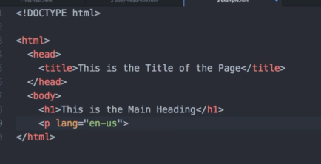

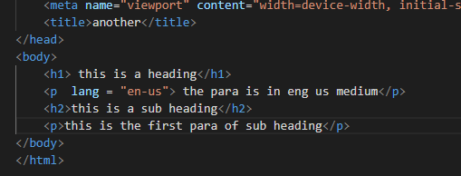

View source = ctrl + u , you can view code behind of a website.

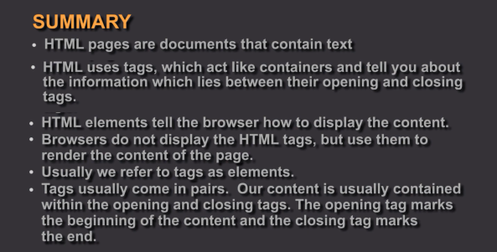

Attribute = contains additional information about tags values.

Structural markeups = headings paragraphs

Symantic markeups = additional information

Html has 6 levels of headings

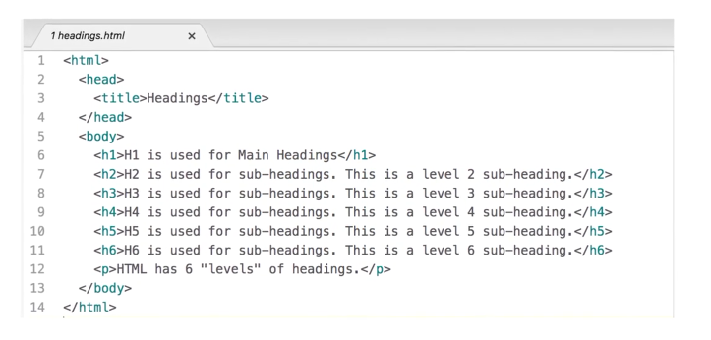

H1 = main headings

H2 = sub headings

H3 , h4 , h5 h6

H6 used for smallest heading

***Paragraph tag :***

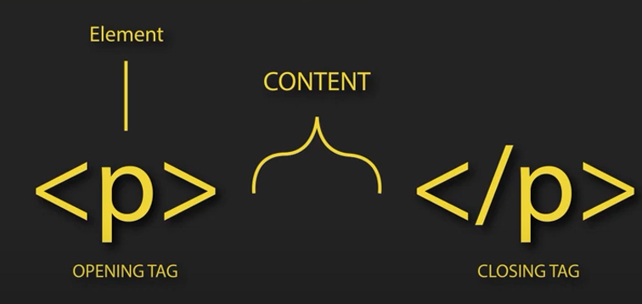

Showed in new line.

Bold para tags:

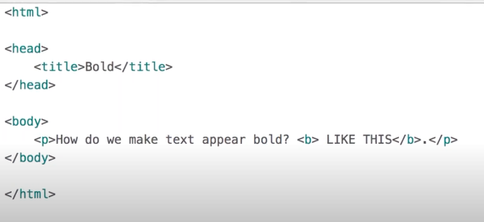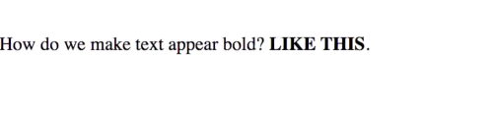

Para italic tags :

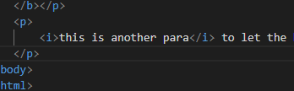

superscript tag :

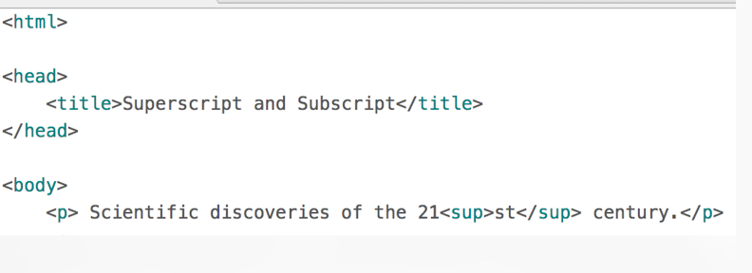

Making text becomes like power called super script

Subscript tag:

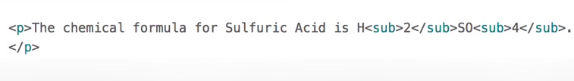

Same as subscript making text becomes like power of something.2^2

***White spaces:***

Despite giving line spaces we don’t see any spaces between text called space collapses.

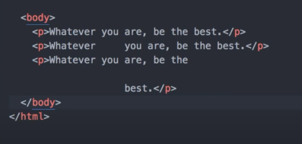

***Line breaks & horizontal loops:***

If you want breakline between para texts.

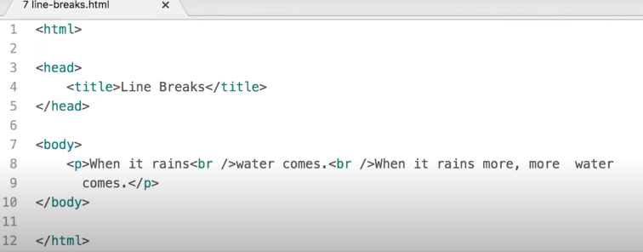

For breaking we also use horizontal lines

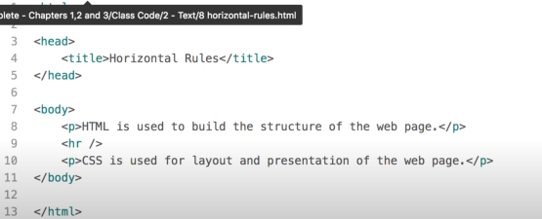

Breaking between two topics. A gape is made afterwards adding hr tag.

Breaks the page into two sections.

***Semantic markups :***

Don’t affect structure but adds new information.

Supports search engines and screen readers.

Strong tag :

Helps screen readers to know the word is bold.

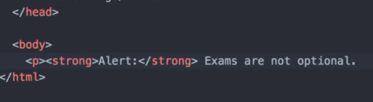

***Emphasis tags :***

Em makes word texts paras italic.

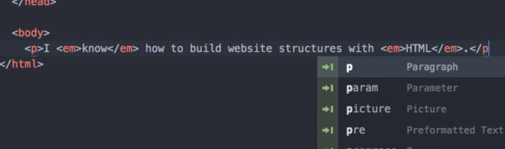

***Quotations tags:***

For that we use blockquote element.

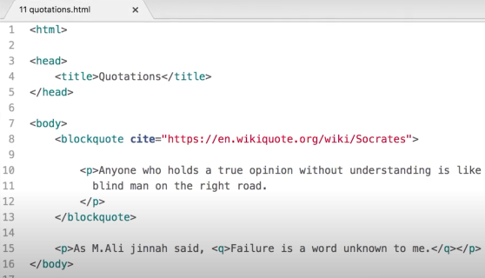

Whenever someone search quotes this text will appear for screen reader also text become some indent.

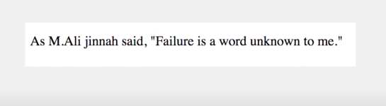

***Acronyms and abbreviation author address :***

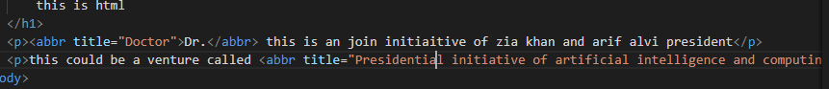

A small popup showed of abbreviation. As doctor if we hover mouse.

Address contains emal address location address etc showed in italic. Contains author details. Address tag it called.

***Citation and definition :***

Giving reference of some text fetched out from another website.

Wnna give reference of somewhere.

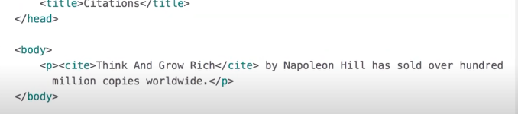

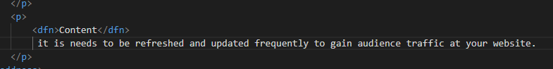

***Changes in content :***

Doing simple insert and delete from which a word is replaced by other.

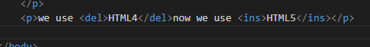

S is called strikethrough.

It represents later price to current price.

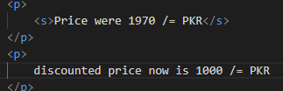

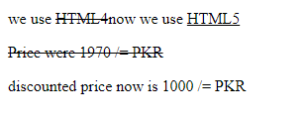

Example :

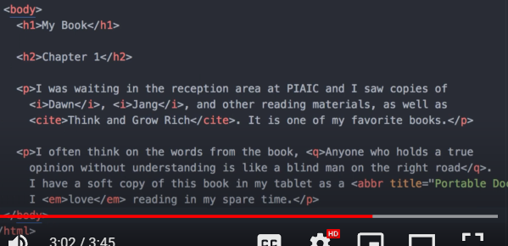

***Ordered and unordered list and definition list:***

There are three types of lists in html ordered unordered and definition list

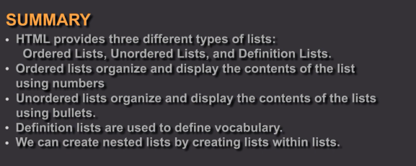

Number of items in a sequence that is managed and by default items indented.

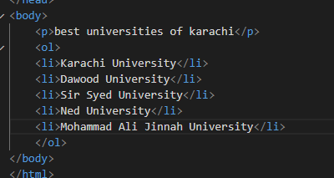

Unordered list:

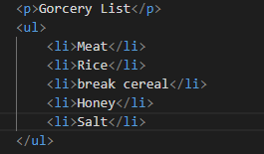

Two terms used for the same definition term and vice versa. 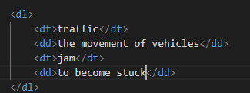 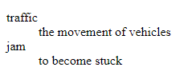

Called dl = definition list , dd = definition data , dt = definition term

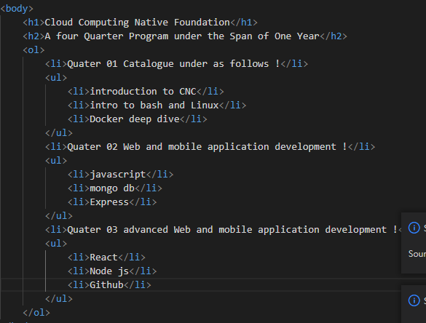

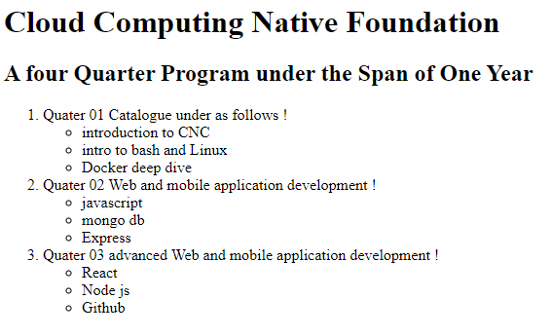

***Links :***

Are used to connect one page to another , or one website to onther wanna jump we use links.

Primary interaction allows in the webpage. Want to move from one page to another. By clicking on links

**Absolute** navigate to same website.

and **relative** url navigate to another website.

**Anchor** tag used to navigate to same page

**Href** = used to define the target of the link , use relative and absolute url.

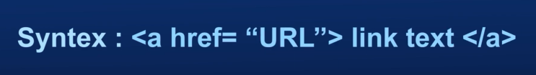

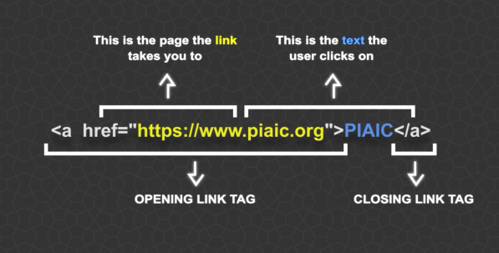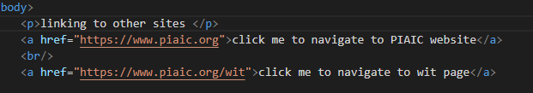

***Linking to other sites:***

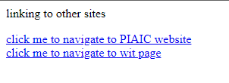

url = uniform resource locator.

Absolute url :

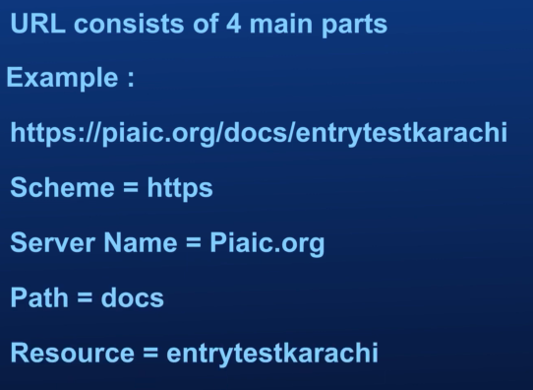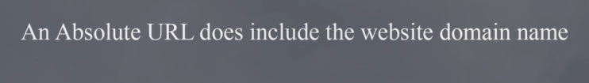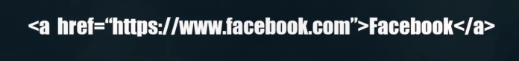

***Relative urls :***

Linking to the other pages on the same site.

Where we jump to home page from other pages of the same site.

Called link building as well.

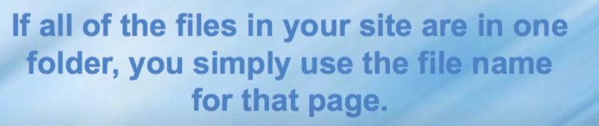

Relative to the current page.

***Directory Structure :***

Organize code in an well structured. And manageable.

Placing pages to each different section of the website making it efficient to access.

Different folders of a website called directory.



Look at the example of online shop :

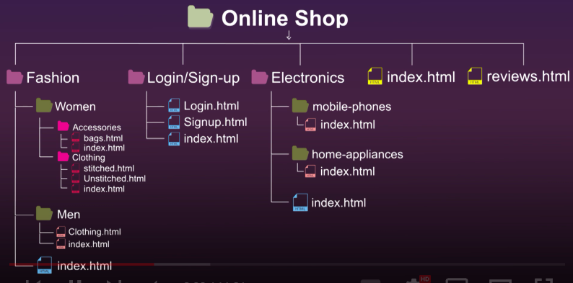

How to access from parent element from child element

How to access grandchild from parent folder.

1. Accessing siblings of the same folder

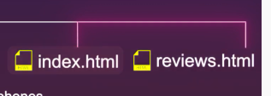



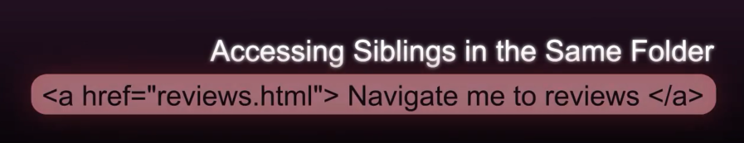

1. Accessing child element

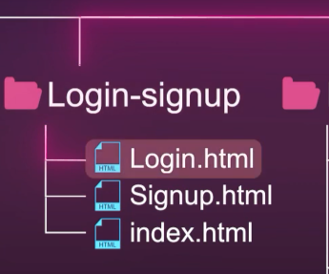

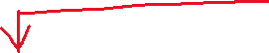

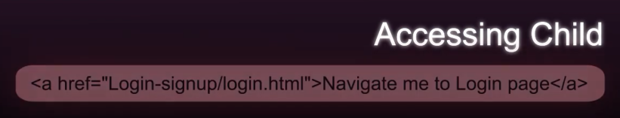

1. Accessing grand child

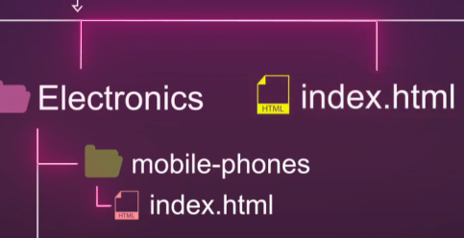 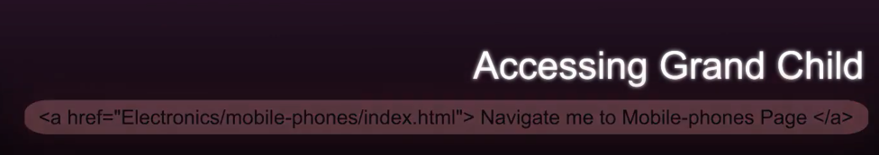

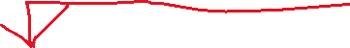

1. Accessing back to index.html

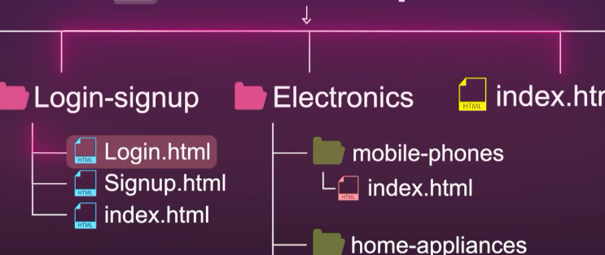 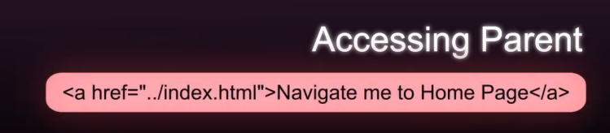



1. Accessing grandchild from grandparent

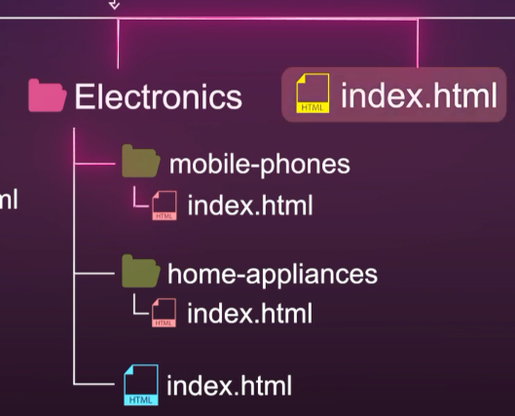 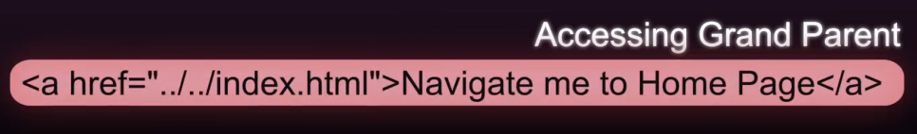



***Look at examples :***

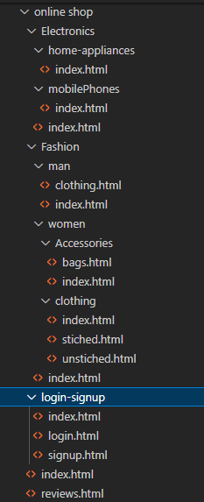

1:

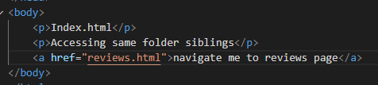

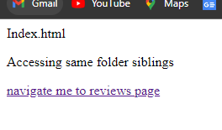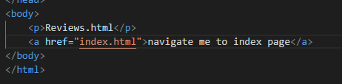

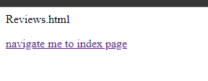

2:

 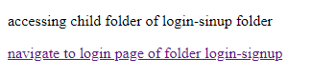 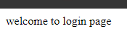

Back to the index.html page.

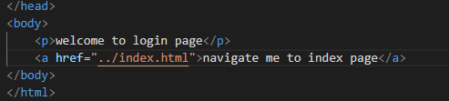

3:

Accessing file of mobile phone folder , where it is the grand parent of electronics folder.

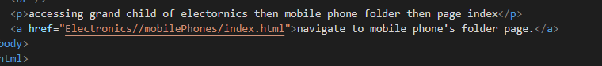

Going back to main page

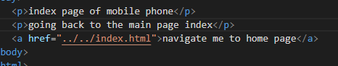

***Email links :***

Wnna add email option any user want to send you query he she’s queries directly shown at your email.

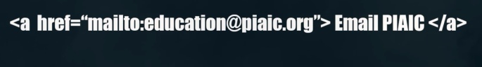

Open links in new window:



Linking to specific part of same a page:

For that manually we use scroll bar to scroll down there we can directly do this through below method:

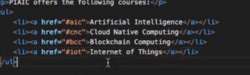

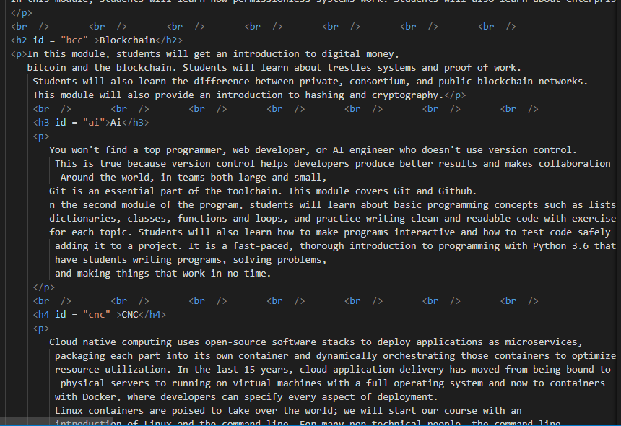

Go back to top :

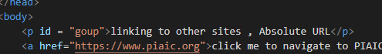

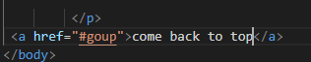

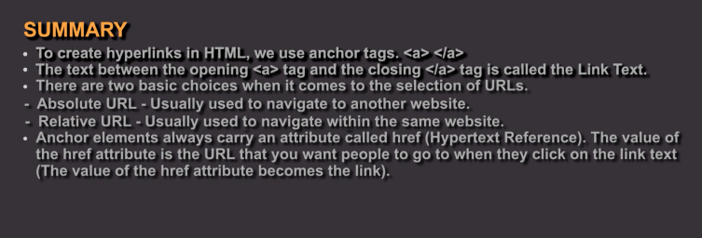

***Images:***

We use image tag for that.

Right format size of image upload and how to upload adding images.

Alt , src , title and img tag is used all this makes a image addition.

Alt tage : is used to display text until the image didn’t load yet also show description of an image.

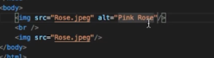

We can specifiy image size with height and width.

Title is used whenever person hover a mouse over pic then it shows whatever you write in the title.s



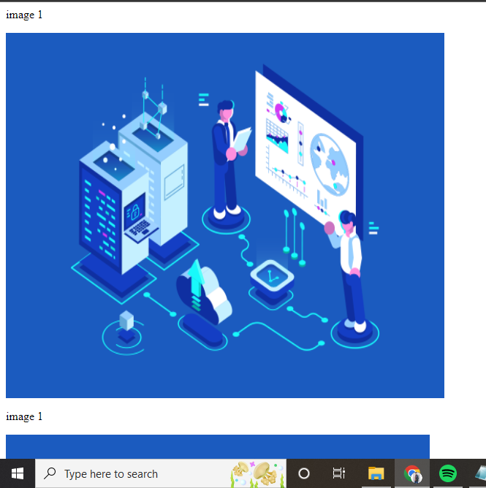

Images place (alignment):

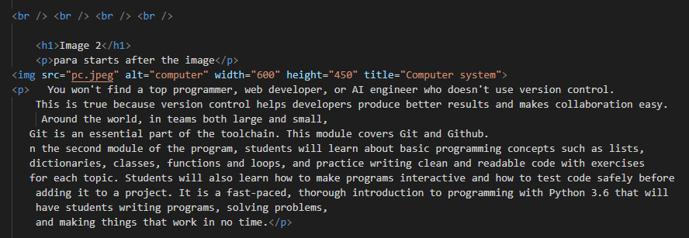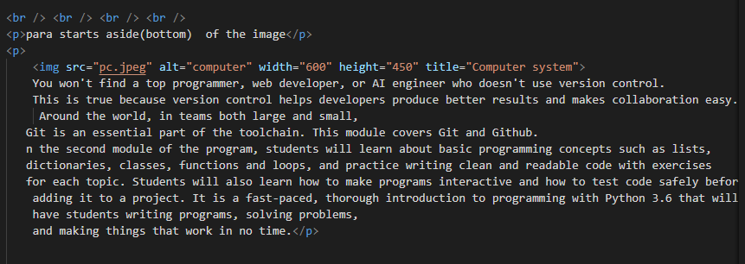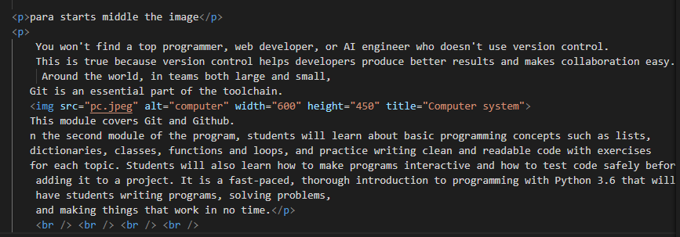

Align images horizontally:

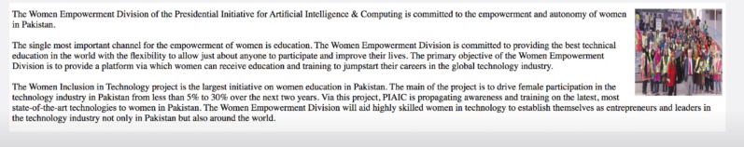

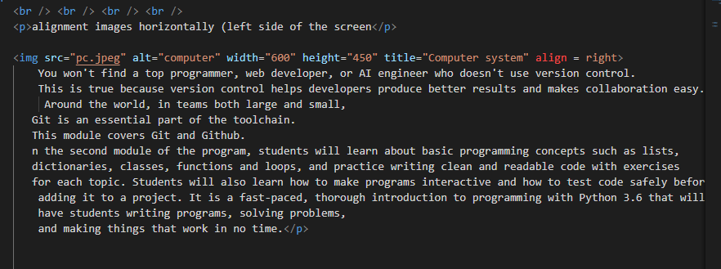

***Vertical align:***

Para goes on top , where image goes on left.

Align to middle of the image.

Give align attribute value to bottom:

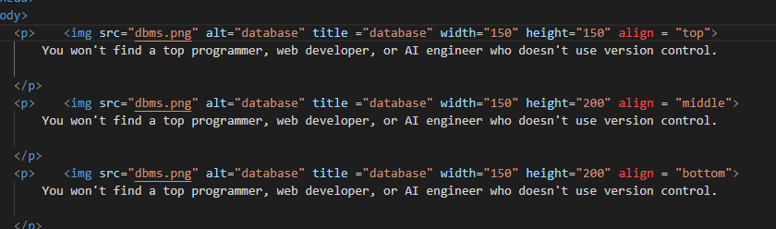

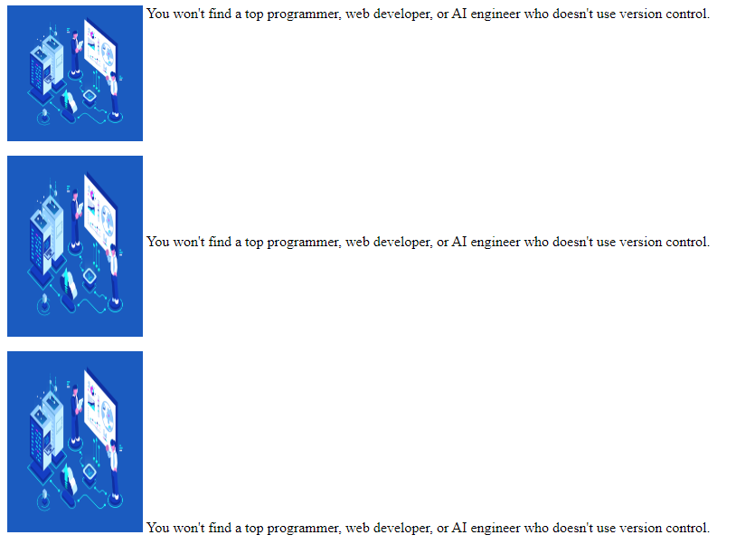

***Image rules:***

Save image on the right size. Specifiy accurate image size. Otherwise image sometimes load so long or wont load.

Try to add image with not so high rate pixel but on appropriate factor.

***Image fomate:***

Jpeg = joint photographic experts group. Images with different multiple colors we save image format in n=jpeg.

Adobe photoshop color picker highlight that.

Png = Same colors large areas where a color is highlighted a lot with multiple colors.

***Gif:***

Add animations in the page using gif image.

***Image resolution:***

72ppx = bitmap images.

 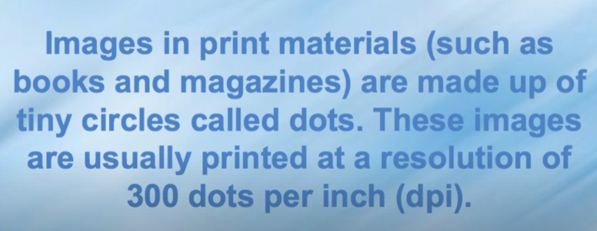

***Image vector:***

Resolution independent images , used for logo and description making ,

This images developed on adobe

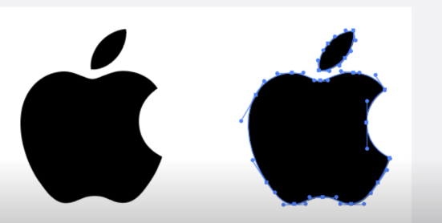

Dimension increase don’t degrade its quality.

***Figure and figure caption:***

With figure element we can add caption to an images and than give fig caption.

Helps screen reader and search engines indicate image details.

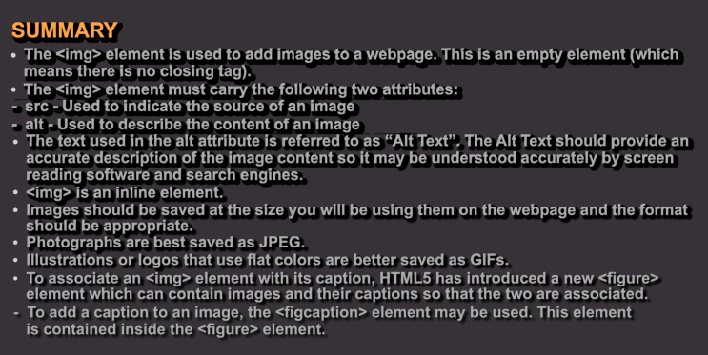

***Table structure:***

Tr=table row

Td=table data

Th = table heading col = column , heading for a row.

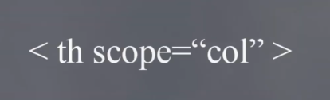

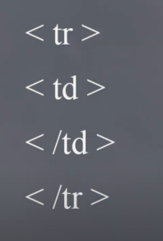

***Spanning:***

***Columns/rows:***

If we give call span value 2 then 2 column under span attribute value will take.similar situation for row but in horizontal direction. --- (

Rows:

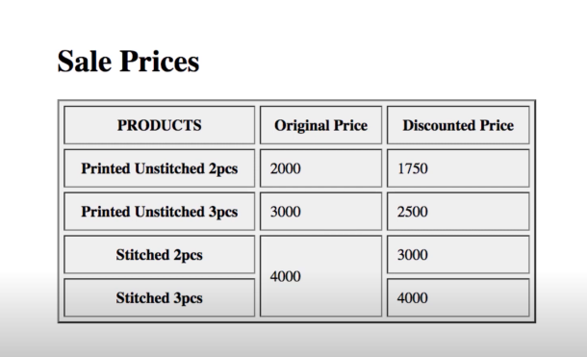

Columns:

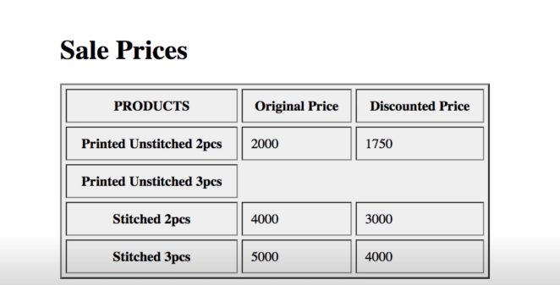

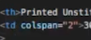

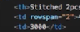

***Long table :***

It divids table into different working pieces such as:

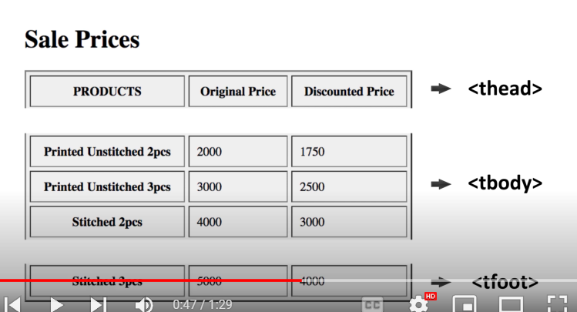

***Width and spacing :***

This function is used in old html , now css replace it.

Attributes are always in opening tag.

Now look at width attribute.

Example :

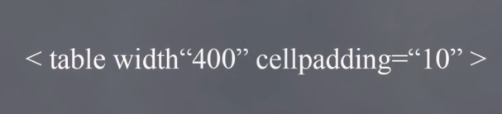

Example 02:

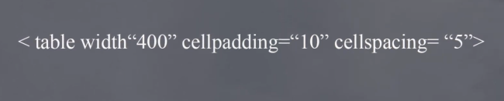

To give space between cells in a table.

***Border and Background :***

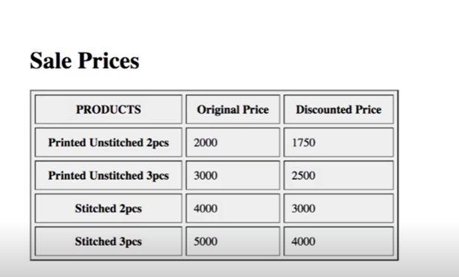

Specify border width:

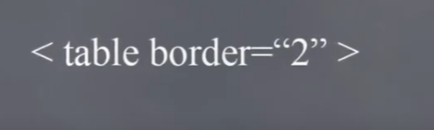

To give background color:



Give color names of haxcode.

Cell padding = gives space in a each cell

Cell spacing give spaces between each cells.

Example of all above work:

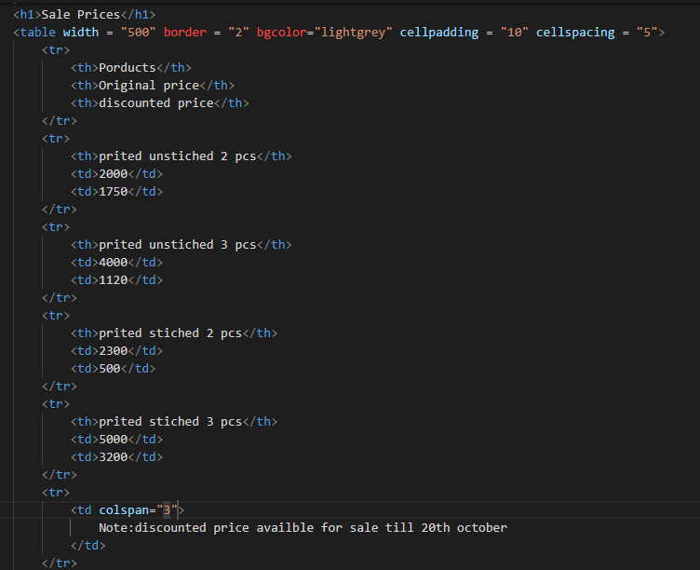

Output:

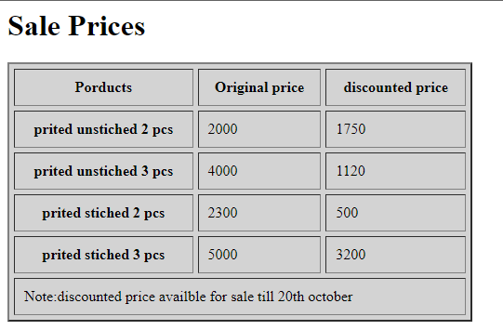

Now for thead , tbody , tfoot Example:

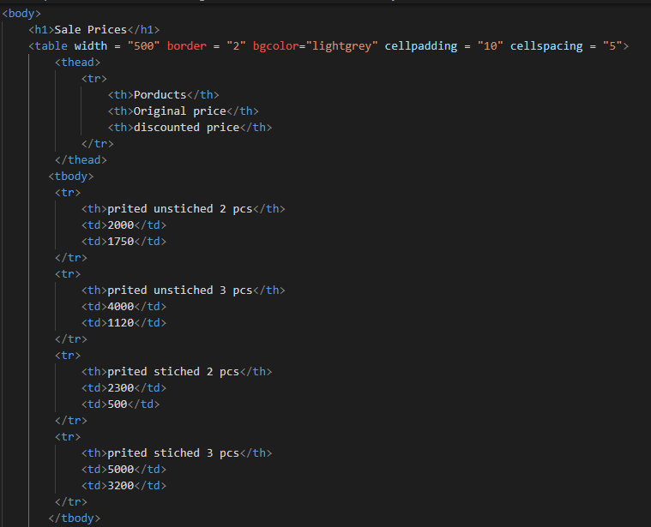 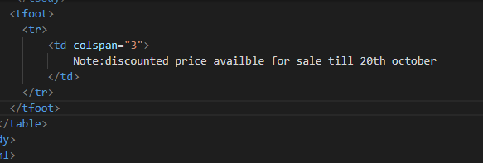 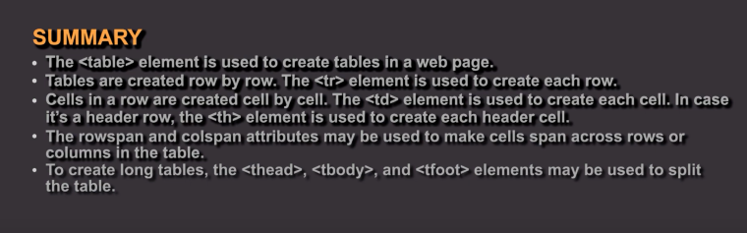

***Forms:***

Is a document we fill to give our bio , personal information is collected through them.

To collect user information. 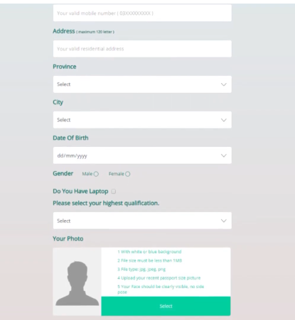

Form controls:

Where a number of fields availbale , which is used as options we want in a form.

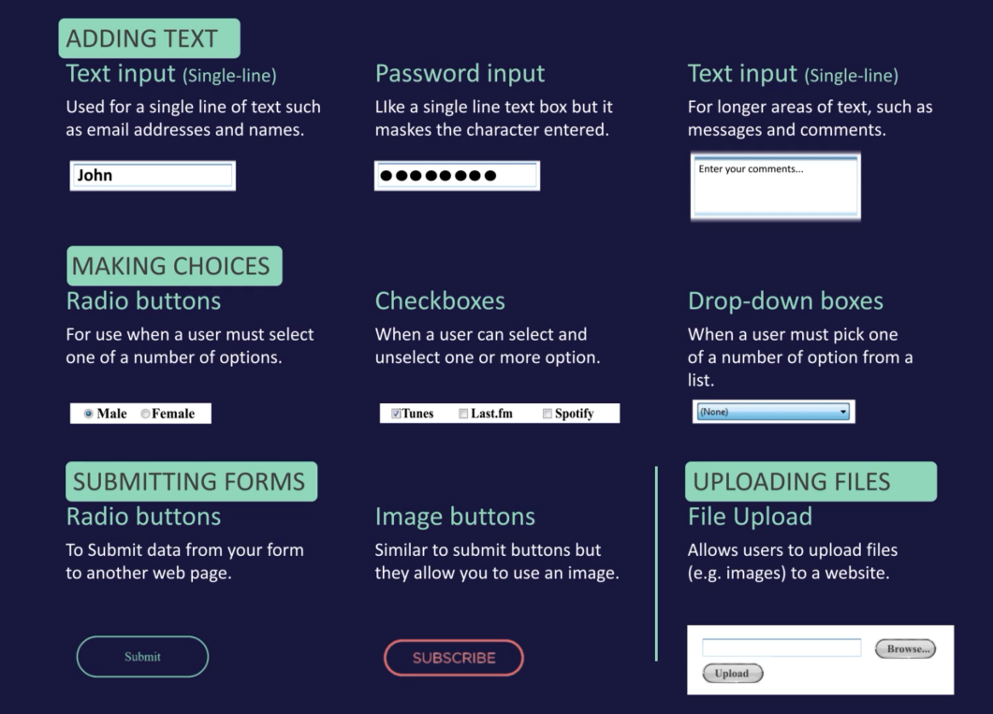

All data we feed in the form a server will catch data. And process that data.

And from there we can fetch data.

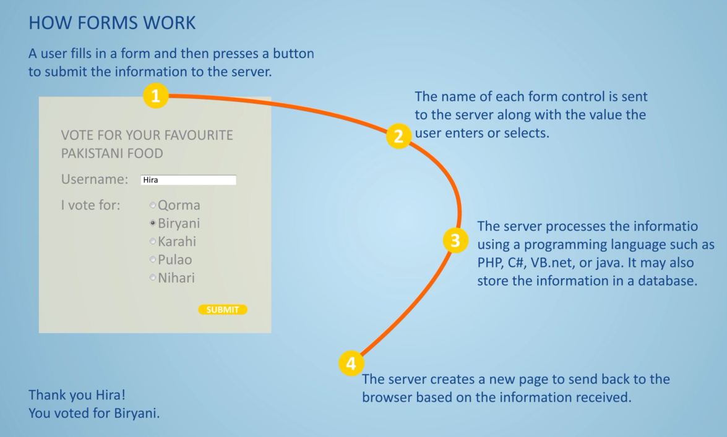

***Form structures:***

Collect information from users.

Through form elements we make basic form structure.

An elements contain action and method attributes.

We can sent data through get method

Post method -> we sent sensitive data through it. 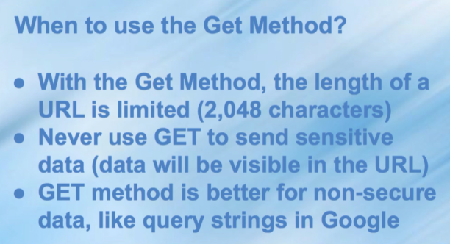

***Form Input:***

Give input type text to get input from user in the form of text.

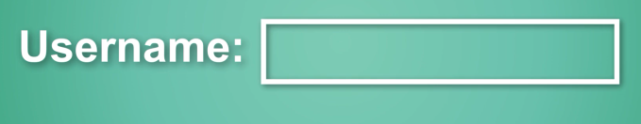

We can same give password in type so characters entered by users goes hide accordingly.

***Text area:***

Opening and closing text area any text between them will appear in the box.

This is a default message appear.

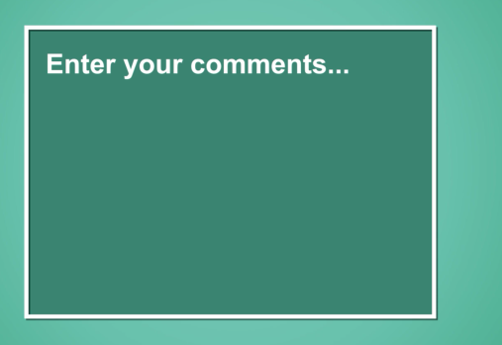

***Radio button:***

A choosable value to be selected by the user in the form of dot input a user can select. If we give input type value radio a radio button is made accordingly.

Similar with checkboxes. But we can select multiple options on that.

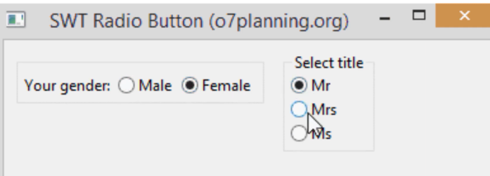

***Dropdown or select boxes:***

Select any one option.

To create dropdown list we use select element.

It contains two or more elements

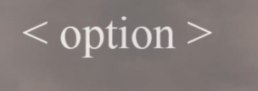

***File input box:***

We give input type file , a user can able to browse and upload a file in the website.

***Submit button:***

Sents form to the server to save information user give.

***Grouping forms elements:***

a section box and field set element under we insert

so we can link input boxes for either to file that or that box

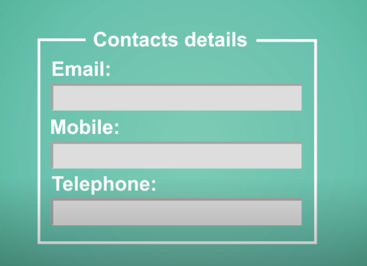

 

We use legend aur opening tag of fieldset where fieldset creats sections.

***Form validation:***

We can checkmark through this feature if we want specific information in the form and let user to restrict user to input right information in right format.

***Input date:***

If we give input type value data , a calendar open for that ie date of birth.

***Forms Practical:***

We can create login , sign in , data input , survey forms etc.

SignUp form :

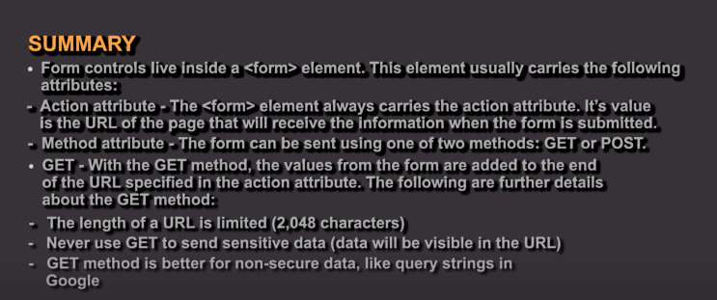 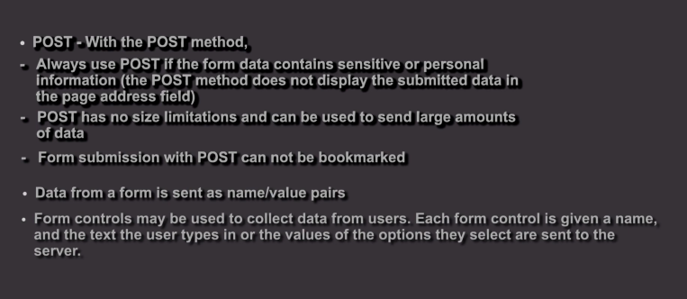

***Comments in html:***

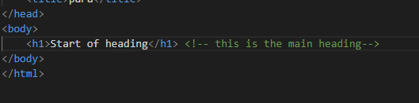

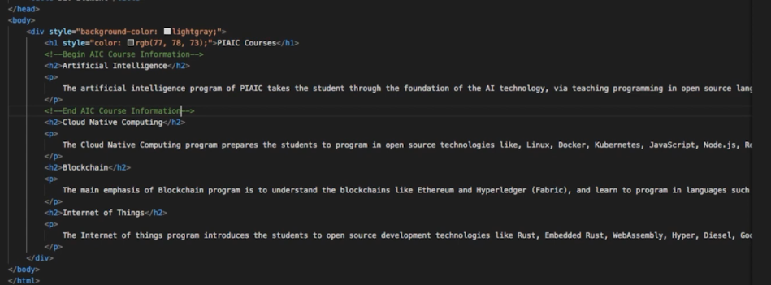

***ID attribute in html:***

To identify one element from another.

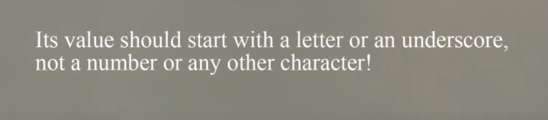

Uniquely identify elements.

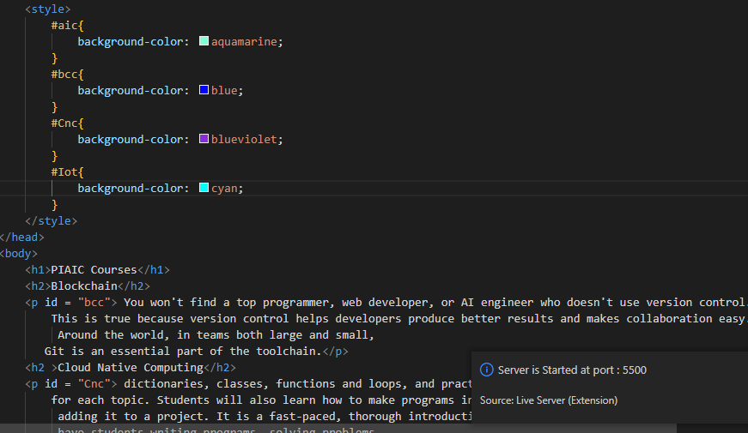

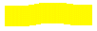

***Class attribute in html:***

Style multiple elements using one style.

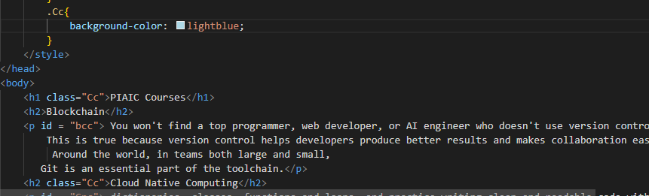

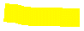

***Block level and inline elements in html:***

Block level means every element starts with the new line.

Inline same line display elements result. 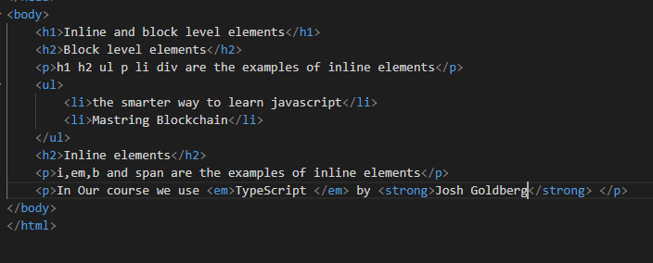 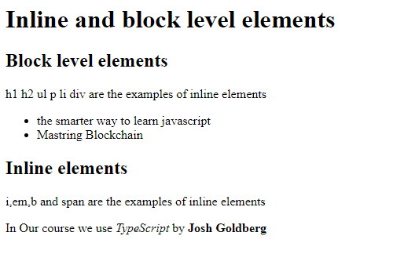

***Div elements in html:***

to manage structure of the page. Want to group set of elements in block level box.



Manage page structure. And adjust set of elements in div.

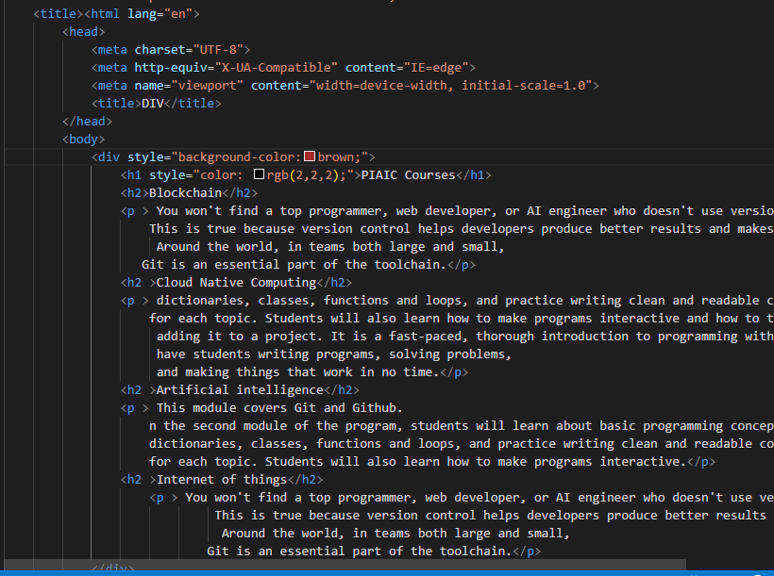 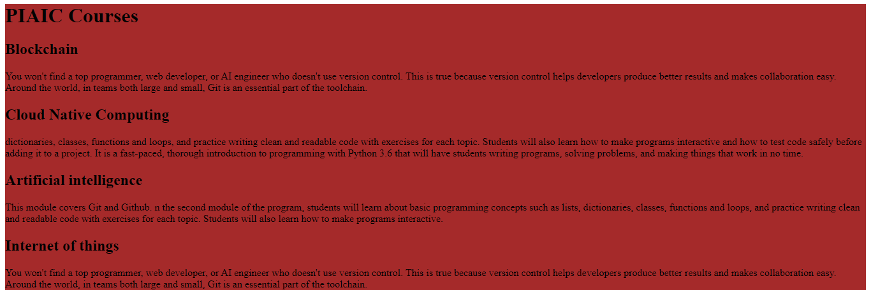

***Div vs span elements in html:***

